FRONT END – PART 1
COMPLETING RESUME

(Break Long Words)
1. Which property can be used to insert line breaks within words to prevent text from overflowing?
a) overflow-wrap b) word-break
c) break-word d) line-break

(Create a Gradient)
2. Which of the following will create a gradient?
a) gradient: linear-gradient(red, blue); b) linear-gradient: linear-gradient(red, blue);
c) background: linear-gradient(red, blue); d) background-color: linear-gradient(red, blue);
e) background-image: linear-gradient(red, blue);

(Number of Colors)
3. What is the required number of colors to produce a gradient effect?
a) One b) Only Two
c) At most Three d) More than one

(Set the Direction)
4. Which of the following are the correct values for the 'direction' option in 'linear-gradient' property?
a) 40deg b) to right c) to left top
d) to right bottom e) to bottom side f) -20deg

(Radial Gradient)
5. Which of the following argument is not accepted by the radial-gradient() function?
a) Shape b) Time
c) Color stops d) Position

(Control Direction)
6. Suppose you want to control the direction, and you have to give the gradient a specific angle to create a horizontal gradient running from left to right.
Which of the following angle will be used?
a) 0deg b) 90deg
c) 180deg d) None of the above

(Not Pseudo Class)
7. Which of the following is not a pseudo class?
a) link b) visited c) active
d) hover e) clicked

(Color Unvisited Links)
8. How will you set the color of all the unvisited links in a web page?
a) a { color: red; } b) a:active { color: red; }
c) a:link { color: red; } d) a:links { color: red; }

(Revisit a Link)
9. Suppose, you clicked on a link and its color is changed when you revisited it. Then ,which of the following pseudo class would have been used to do so?
a) link b) active
c) visited d) checked

(Transition timing function)
10. Which of the following transition-timing-function property specifies a transition effect with a slow start and end?
a) ease-in b) ease
c) ease-in-out d) None of the above.

(How to Style This)
11. How can you apply styles to first line of every paragraph?
a) p::top-line { … } b) p::first-child { … }
c) p::first-line { … } d) p::first { … }

(Add Image at Start)
12. Which of the following pseudo element will help you add an image before every paragraph, using CSS only?

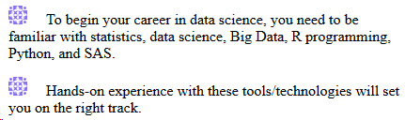

a) p::first-line { … } b) p::before { ... }
c) p::after { … } d) none of the above

(Find the Output)
13. What will be the output of the code given below -

<!DOCTYPE html>
<html>
<head>
<style>
body {
background-color: #f1f1f1;
}
p {
margin: 0;
}
p::first-line {
font-size: 1rem;
font-family: monospace;
}
p.name::first-letter {
color: #ff0000;
font-size: 2rem;
}
</style>
</head>
<body>
<p class="name">The Divine Tales</p>
<p>In a small room in a once-abandoned government building, a young man, no more than eighteen years of age, was standing in a metal tub as two attendants tended to what seemed to be important preparations.</p>
</body>
</html>

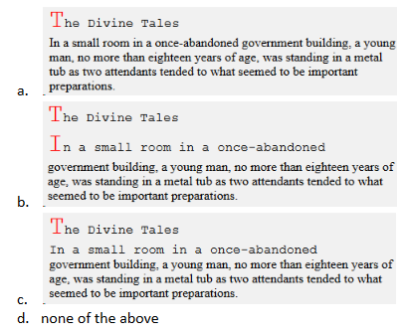
a) a b) b c) c d) d

ASSIGNMENT

(Overflow Wrap)
14. What value can 'overflow-wrap' have?
a) break-line b) word-break
c) break-word d) line-break

(Types of Gradient)
15. Which of the following is/are types of gradient?
a) Linear Gradient b) Radial Gradient
c) Circular Gradient d) Repeating Linear Gradient
e) Repeating Radial Gradient f) Repeating Circular Gradient
g) None of the above

(Gradient Looks Like)
16. Given the below CSS code, when applied to an empty div will look like -

div {
height: 150px;
width: 200px;
background-image: linear-gradient(red, yellow , green 100%);
}

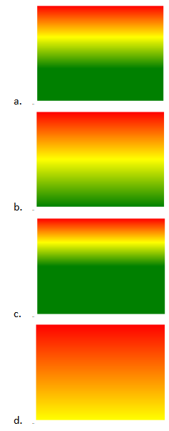

a) b b) a c) d d) c

(Repeating Gradient)
17. Given the below CSS code, when applied to an empty div will look like -

div {
height: 150px;
width: 300px;
background-image: repeating-linear-gradient(45deg, #9e6df9, #f77656 25%, #5ffc87 50%);
}

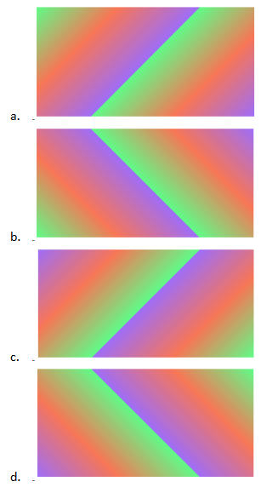

a) b b) a c) d d) c

(Add Image on Right)
18. Which of the following CSS code will add an image on the right side of every anchor tag?
a) a:after { background-image:url(...); } b) a::after { background-image:url(...); }
c) a::right { background-image:url(...); } d) a:right { background-image:url(...); }
e) none of the above

(Style on Clicking)
19. Given a page having 2 links and then 2 paragraphs, is shown below -

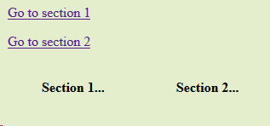

On clicking the second link, the 'Section 2...' gets highlighted as shown below -

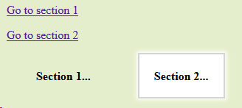

What could be the possible pseudo class/element that has been used?
a) a:target { ….. } b) a:target p { ….. }
c) p:target { ….. } d) p::target { ….. }

(Select Even Elements)
20. How will you select even <p> tags that are contained inside a <div id="even"> tag?
a) #even:nth-child(2n+1) { … } b) p:nth-child(2n) { … }
c) #even p:nth-child(2n) { … } d) #even::nth-child(2n+1) { … }

(Order of Pseudo-classes)
21. Which of the following is the recommended order of Pseudo-classes?
a) :link, :visited, :focus, :hover, and :active. b) :visited, :link, :hover, :active, and :focus.
c) :link, :visited, :active, :hover, and :focus. d) :link, :visited,, :hover, :active, and :focus.

(Z-index)
22. Which of the following statements is true about z-index?
a) Z-index only affects text elements.
b) Z-index only used for pseudo-class elements.
c) Z-index only affects positioned elements.
d) Z-index only affects absolute positioned elements.

(Right Index)
23. Suppose you want to arrange five numbers of DIVs so that DIV4 is placed above DIV1. Now, which CSS property will we use to control the order of the stack?
a) X-index b) Y-index
c) Z-index d) None of the above.

**********

